Cross Platform Considerations for my Side Scrolling Game
By John Hannon

Coding for both android and Windows platform needs a lot more considerations than what I’m used too. It has a lot of different considerations. The way things look and how the game manages different screen sizes. I had to consider things I’ve never considered before. This made coding and developing this game more difficult than what I’m used too.
The first of these concepts is scalability. While developing I was always trying to be conscious of making code that can be applied to many different objects. For example, my collision code can just be applied to the objects and will work. I made movement and rotation also work like this. I wanted code to just work when they are attacked. This would be like a component.
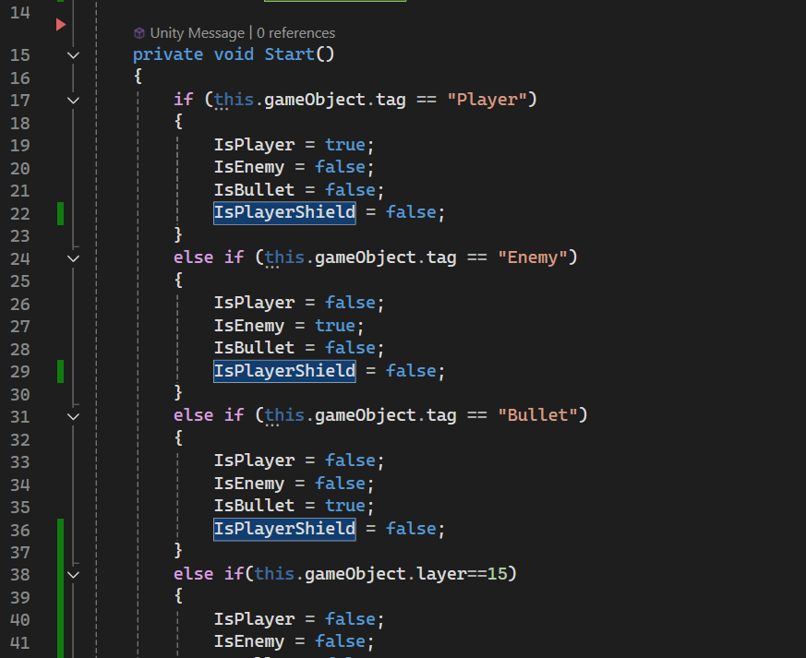
CollisionManager Script lines 14 to 41
The above script is an exert showing how this collision script works. We check what type of object is colliding and them check what they are colliding with. For this we just set up with a simple variable to confirm, these variables just check which object type is using it and what should happen if a certain interaction happens. In the above script we use tags and layer to confirm what object is both being hit and colliding with others. By using tags and layers I also manage the collision of what can collide with each other. This allows me freedom to guarantee that certain collisions work the exact way it is.

The next consideration was how the users would have to interact with this game. Pc and Android gamers play games in a unique way. While Windows have an entire keyboard and mouse to use, Android players must use a touch screen. This makes making the game more difficult as you must accommodate for the android users limited controls. You can’t have as many different inputs as android couldn’t handle this without losing there screen to buttons. You could make many different systems automative but that could take away from the player the ability to choose when to shoot. Movement could be done through either a joystick like system or a click and move system. I taught the click and move system, that while it would be simpler, it would also obstruct the users screen and with how the game would be more difficult later on would make the android use blind to enemies when clicking with their fingers. While this could work on pc it just doesn’t work out overall on android. So I decided to use a different idea. I let the pc user use the keyboard and gave the Android user a stick that will direct the player around the screen. This seemed like the best way to implement a fun system that also met my addition requirements of being able to accelerate and decelerate. For shooting I added a simple button on the screen that the user would just have to press it and while it may get in the way of some enemies it was the only real way to let the user have control over when they shoot. I was also considering a future development of this game of tracking player stats like hit percentage. I kept it in the corner to also compliment the android users playstyle or two hands at each side. To make this work I made a system check to see what platform the player was on to make sure the correct controls were displayed. We check for both android and pc users.
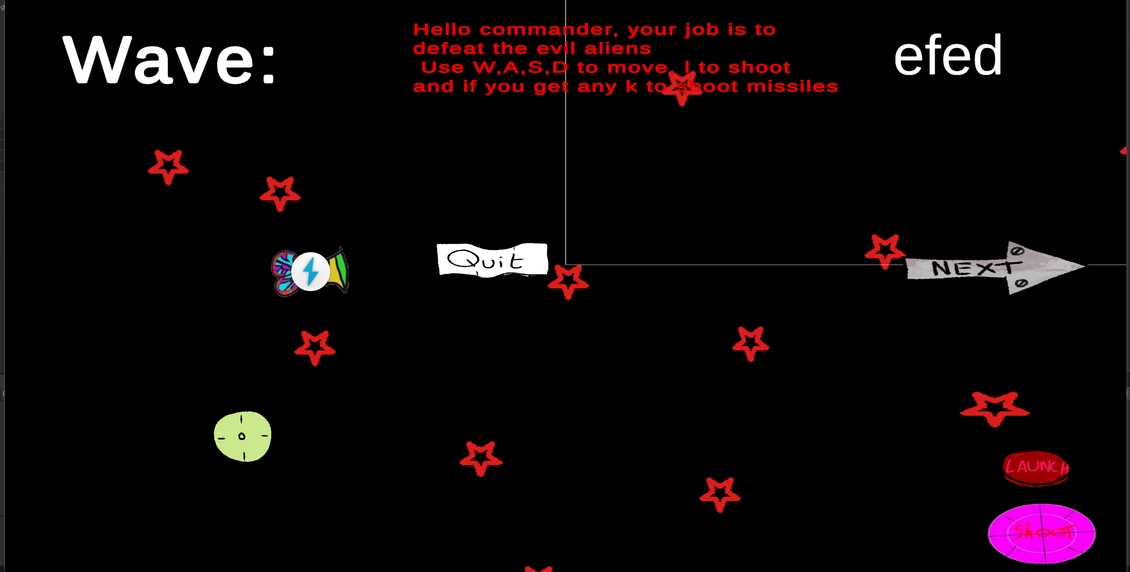
MainScreen for an android user game currently not running
Above you see the design of the screen for an android user. A joystick on the left with the two shoot buttons on the right.
The Pickups where also designed around android players in mind. Players on pc can use many different buttons to control the player and would mean I could add numerous different ideas. Originally, I wanted to make the pickups all be different types of ammo the player can pick up and then switch between. I changed it to be only one ammo type later in development. The ammo I chose was missile and left a missile button the player could interact with on screen. This would be able to be fired whenever the player got a missile. The next two pickups I added where double shot and a shield. Both are activated automatically as I didn’t really want to add more buttons around the screen.
When I added text, I was also conscious about how much of the screen I took up as I wanted to get a mix between readability and also not being in the way of the player.
When designing characters, I struggled in designing as the detail of the character would be lost to a person on android. I was conscious of how exactly the design would translate as each sprite would lose a lot when these problems would occur. With this in mind I started having the drawings made simpler. I wanted simple ideas that worked with not much detail as the detail would be lost

(not done subsection)
System Architects
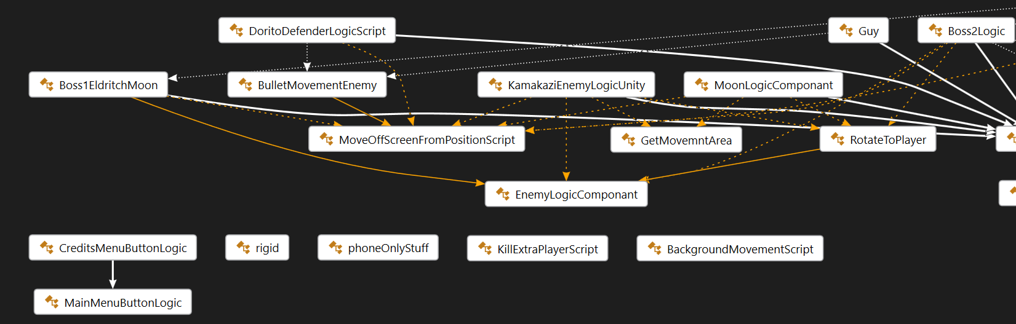
Class Digram Left Side
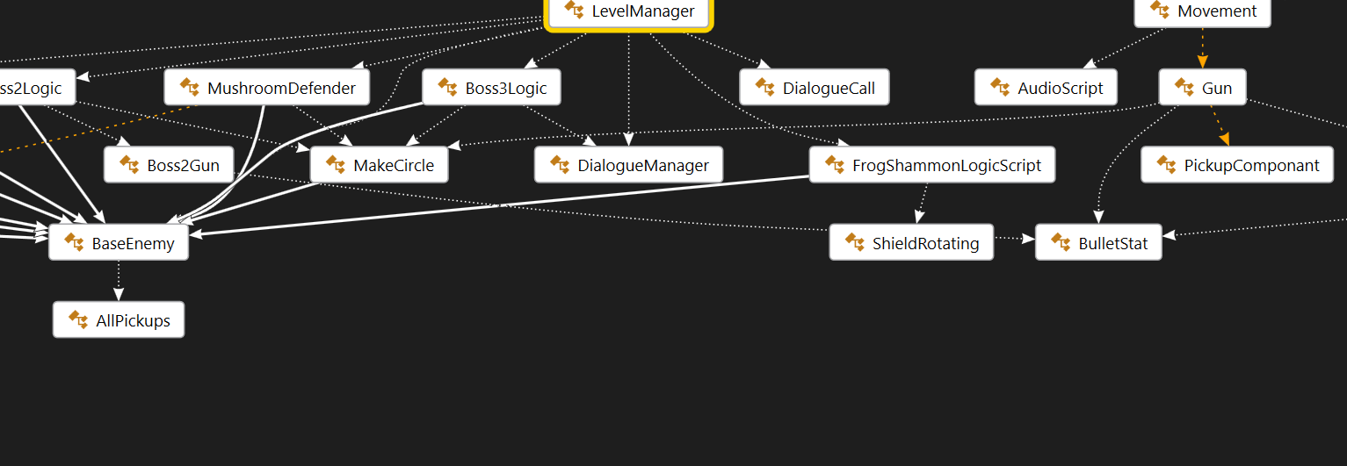
Class Diagram Middle
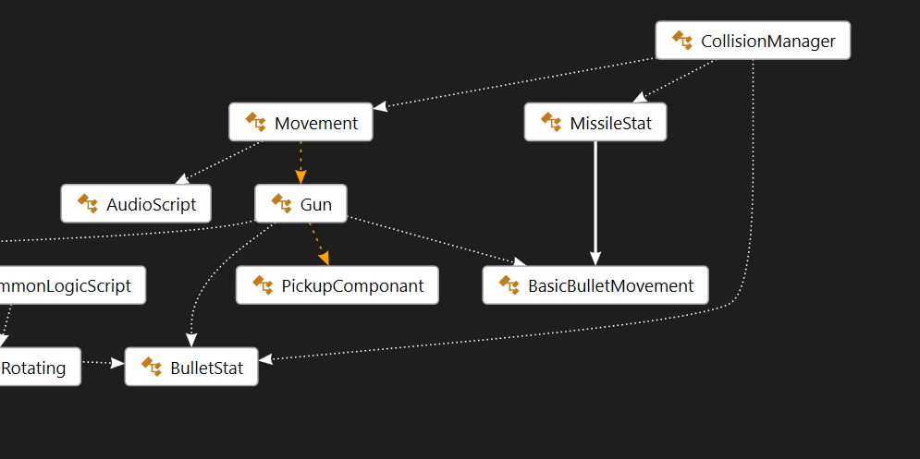
Class DiagramRight
Above is a class diagram of all of my classes. In many cases I have other objects reference. Like in collisionManager I call certain objects when certain collisions happens. With bullet stat we use this to call for the damage of each bullet. MissileStat work the same way. For orange line this is when the object holds an object its pointing at. Movement owns a gun and gun holds a pickupComponent. The last white line is the inheritance. The main inheritance I use is BaseEnemy. For a simple example of a sequence diagram lets use the simple Mushroom Defender class. In this sequence would be during the game when they have already spawned.
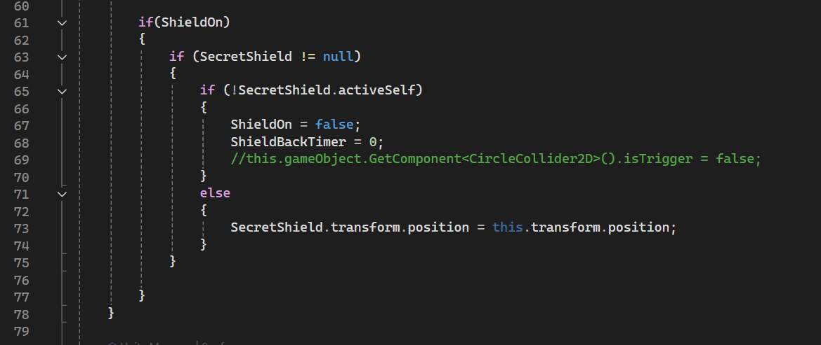
Mushroom Defender update function lines 60 to 79
The mushroom defender uses a shield that it spawns to defend other enemies. Shield On is a variable we use to check if the shield is currently active. If this is true we then check if its null and then if not active we enter into the third if statement. Since we know the shield is not on, we state that it is and set a timer to 0. This happens if the shield took too much damage.
If the Shield is active, we just move it to our position.
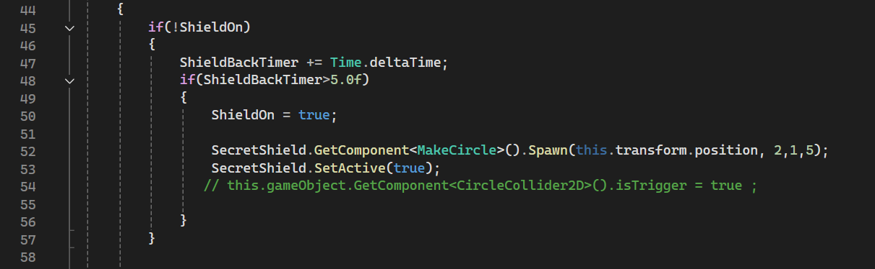
Mushroom Defender update function lines 44 to 58
Since the shield is off, we increase the timer on line 47. When this timer reaches five seconds or more the programme them turns on the shield by spawning the shield again setting its health and other stats. Last we set it active on line 53.
2 -Provide appropriate critical analysis and conclusions about developing this 2D game in Unity. Think about and discuss how developing in Unity is similar or different to developing in C++
Unity uses CSharp a language based of off c++. It is a more secure language than c++. When developing in c++, I had to make everything myself. From the collisions to sprites to each individual thing. We used sfml with c++ and I personally didn’t like this. It felt limiting. While coding in unity feels like I have so many more options. Its like I could code nearly anything. It very similar in feel and look. The class structure is incredibly similar. How to make objects is similar as well. I don’t know if the feel is due to difference of experience. I do really like how unity works with its organizational structure. It makes it easier to manage all the separate file, to animate it and to work with different variables.
I would say it is much better to work with C# over c++ while you lack pointers, it simplifies so many other things. It as I said makes the project so much simpler and easier to work with. So to conclude its so much better than coding back then in just the visual studios editor.

Part 2 – Game Design

This game takes place as you an invader is attacking an alien planet. You are told its for revenge for an act the planet did. The game takes place across three levels. Outer space just outside the planet, in the planet’s atmosphere and then in the capital city of the planet. The player controls one person made of both butterfly wings and a bat wings. The player goes through ten waves each level and then a boss wave. Throughout the waves the player can get different pickups that can increase their power. They can gain missiles that deal explosions damaging multiple enemies. A double shot Powerup allowing the player to shoot multiple knives at once and lastly a shield that defends the player from the damage taken. Each boss uses elements of the enemies discovered in that level gaining numerous abilities.
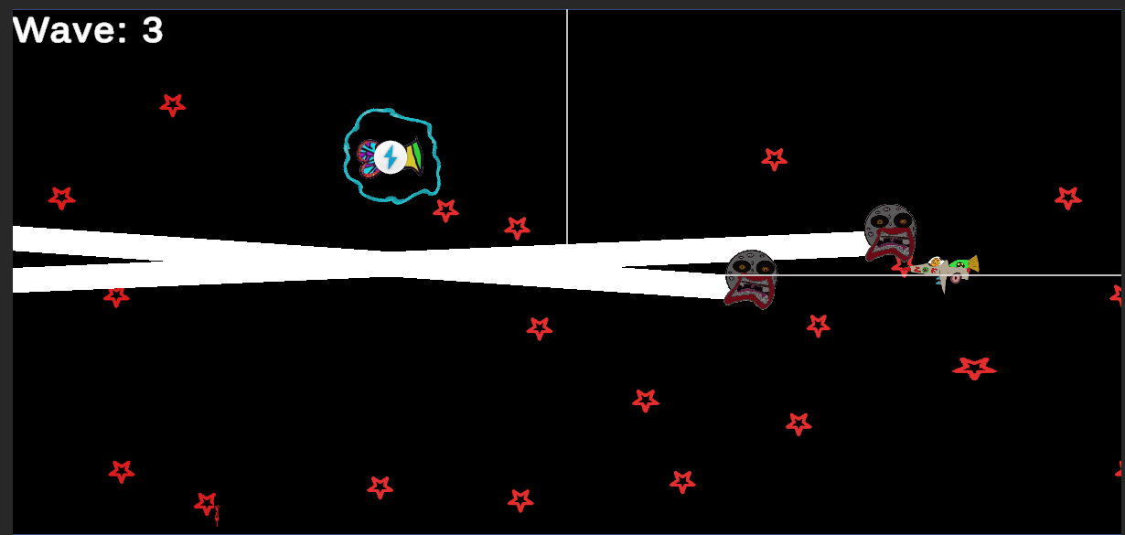
Wave Example Wave 3 level 1 player with shield being shot by two moons and a toad flyer
This game allows players to play the game both on android and on PC. It also gives a unique experience where the user can question their own orders and what they are doing. Although their destiny is set in stone.

Issues OF Cross Platform Development
I had numerous issues when developing this project. This project just loved to break. Bugs were always everywhere. The first issues I had were with movement. The movement was always either too slow or fast. Trying to have a simple movement system was super difficult. I found myself struggling to understand the basic of velocities and basics of movement a common circumstance of myself. I managed to finally make it work through a two-button input system where we track both the up and down direction. I keep an acceleration and a max speed to keep the player from going too quickly. I also remove the speed once it gets too slow so that the player can stop without the speed not slowing own enough.
The next big issue I had was another common my own arrogance and belief that I am going to make the greatest thing ever. I had to figure out how to keep track of player inputs. We can use the Input field to check what button was pressed and compare it to other strings. This was how I wanted to implement this feature as I wanted to give the player the option to change which keys they use for the game. I spent about an hour here realising that the spacebar key is “ “, a literal space rather than a special key. I ended up not doing anything related to this.

Next issue Time management.
I realised on the Wednesday before reading week that reading week was my last week to work on this project. Do to me not realising this I had less time than expected to make the project work. Time was a big factor in my problems there are a bunch f things I would have loved to implement but sadly I couldn’t. The sounds of the game are absent. The story could have more work with more dialogue. I also decided to have all of my image’s custom made.
After four years of game Development, I am still horrible at time management. Even now the pressure of other modules has not helped me to work on this project.

Too much time makes me consider how to do everything in the development, but I don’t code much always saying that its later. On this project since most of the code was developed during crunch time many simple errors and problems in the code were left in with the taught of it can be fixed later to never be fixed. The biggest Example of this is the spawn method
Base Enemy spawn function lines 14 to 18
At the beginning I taught about changing the enemy’s health and speed and even having a rank. These are relics of the original plan of spawning specified groups of enemies. The start target and x and y direction, where developed for the moonEnemy and do work well enough. The rest of health is usually never specified so enemies should just let it be determined. This meant that every time I wanted the spawn function called it had to be this spawn function. There are other examples of code being eft there and unused like the invisible wall’s collision code.
The other main example of time being a problem is found with boss three and the lack of sound. Boss three had two main ideas being it originally. The main ideas where a giant wormlike creature that can detach with more torrents, second it a stationary boss with a giant laser and turrets to shoot the player trying to implement everything the player fought against, Due to time I couldn’t develop this and complete the game. I do find the boss being a false boss to be a more compelling story especially with the themes I was going for , even if disappointing.

Collisions
I understand collisions and how they work well enough but they caused me particular problems in this. I always need things to collide but it never really worked out for me. The player bullet would push back plyer and same for the enemies. The biggest problem I had was when I needed enemies t collide with things but not with the invisible walls. There was just no real solution so I bypassed it by just specifying the area the player could be in and forcing them to go back if they go back.
I did come up with a simple solution to this. Unity allows different objects to ignore each other collision entirely.

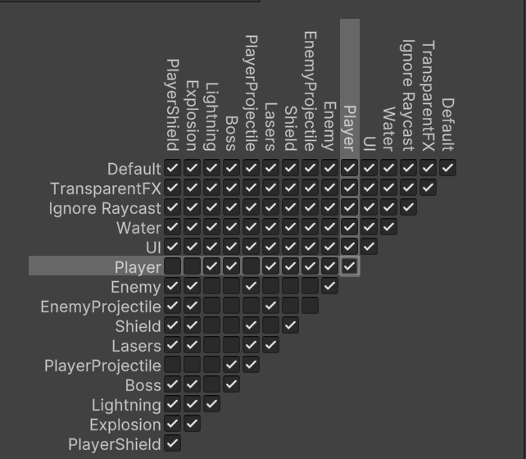
Unity 2d physics collision panel
The above panel show every layer in my game. Everywhere where no tick is has no collision. So a enemy cant collide with lightning. This was revolutionary for me and making this game. Boss two in particular had this problem where the bullets would collide with each other making a vortex of bullets surrounding the boss.
Collision problems unfortunately wouldn’t end there. The lasers Boss one uses are Tagged as Enemy so when the player shot it counts as hitting a boss. When the collision happened since the laser had no rigidbody or method to call and damage to it hit the boss whose rigidbody counted for all its children. This led to my play tester killing the boss without ever hitting it. Other collision problems occurred with the players shield where it would destroy things it shouldn’t be able to destroy due to incorrect tag collision action.
Another problem I faced was enemy. This game was requested to be run on an android emulator and itch. Since itch was a web browser I could not use the normal methods of memory I would like to use. To solve this I started using the don’t destroy on load for the player. This allows the player to keep its stats and more importantly keep all its pickups.
The last major problem I faced in this project is building the project. Itch requires I build the project in webGl. This is neither PC nor Android so all of my code doesn’t work at all. All the code checking which platform it runs on failed entirely. With this I had to quickly find a work around. The main choice I came up with is to just let the user always be considered PC user if not android or WebGl.
Issues I came across while building this project. The size of the screen and the screen text is different from the editor. On itch the frogs teleport doesn’t disappear. The frog’s dues to a smaller screen can now spawn at the edge of the map and also the edge of the map is smaller so the player can leave the screen edges entering into areas the player cannot not see. To fix this I set up soe code to keep the screen to be a certain aspect ratio. This aspect ratio forces the screen to be the way we need to see it. Essentially, I added black bars to the game. I also set up an object that checks the screen size to spawn enemies outside the screen.
I would say one of my main takeaways from this is to not do this again having to consider what my game would look like on one platform is hard enough but since other platforms have different sizes and ways of working its leads to a lack of cohesion where the game would need to account for so many more things than just how the players moves and navigates.

Itch Link
https://silverwolf12.itch.io/invadetheplanet

